# HAZARDOUS AREA MONITORING FOR INDUSTRIAL PLANT POWERED BY IOT

**FINAL REPORT**

# Team ID: PNT2022TMID18942

**Abstract:**

Most of the industries have large machineries that produce heat due to friction. Many industries operate solely on the idea of heat production. They include smelting plants, recycling hubs, waste treatment facilities and even nuclear power generators. So, when these industries produce temperature that they can’t control, the result is catastrophic. This system solely aims on monitoring the temperature of the industry, thereby ensuring the safety of the workers and the industry.

# Objectives:

* This project helps the industries in monitoring the rise and fall of temperatures.
* The alert system will be triggered when the temperature exceeds normal bounds.
* In case of emergencies, the admins will be notified in the same instant the workers are alerted.
* In the web application, admins can view the sensor parameters.

# Problem Formulation:

Any heat escaping the machinery, burners, furnaces, etc. are ultimate sources of temperature increase. This happens either accidentally or out of negligence. This may not affect individuals directly, but can in-turn trigger another event of catastrophic nature, thus ensuring precautionary measures is essential.

The Chernobyl disaster due to the nuclear reactor meltdown at Chernobyl nuclear plant, Ukraine is one such catastrophes. We know that the disaster occurred due to the meltdown of nuclear reactor. But the main reason for the meltdown was the malfunction of the cooling pipes, which caused the coolant to vaporize and thus the colliding neutrons increased the heat tremendously.

These temperature increases can be monitored regularly using various detectors containing sensors to detect any abnormal changes and trends in heat production and temperature increase, thereby allowing the concerned officials to act on it before anything happens to those working in that environment.

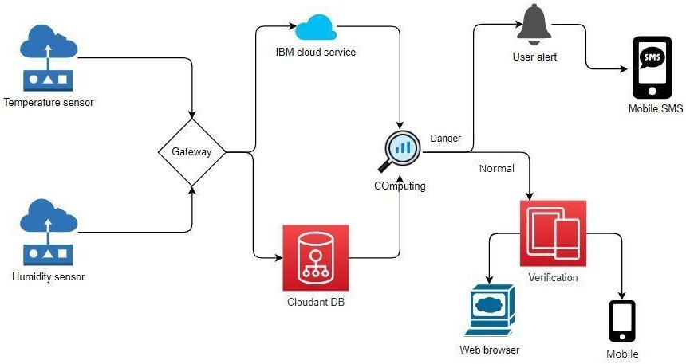

# Solution Architecture:

1. Gather data from sensor.
2. Update the gathered data to Cloud.
3. Display data in Web UI for visualization.
4. Display data in mobile device to authorized individuals.
5. Notify authorities in case of any anomalies in the environment data.

Integrity and data confidentiality are the 2 key security features to be taken care of. Tampering the data may lead to serious accidents. User can easily keep an eye on their industry though they stay at home. This system is similar to a surveillance system

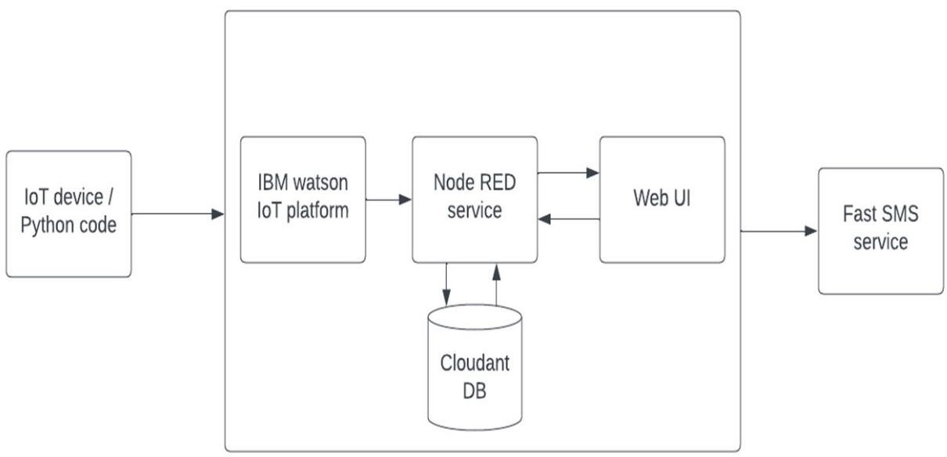

where we keep track of the conditions of the industry to keep the industry and the workers safe.

# Proposed Solution:

## IoT Device:

This is the most important component of the device. As the main goal of the system is to monitor the surroundings, the IoT component is used to perceive the environment to measure the temperature in the area of the industry.

## IBM Watson:

This is used to connect the IoT devices to the network and to use the obtained data to perform various calculations and visualizations to determine if the obtained information is normal or if it has to be reported to the admins for precaution measures to begin.

## Node-RED:

Node-RED gathers the data from IBM Watson using nodes and the data flow between these nodes. This module acts as a backbone to publish data. Node- RED plays a vital role in creating a dashboard where the admin can view the sensed data. At the same time the data is also published in a temporary website, from which our mobile application gathers the data.

## MIT App:

This is the mobile application where the user must login with their credentials to monitor the environmental parameters. This here is made up of several screen for various purposes such as to log in, to raise alarm, and to display the data. An industry might have multiple security personals who might be in need of access to monitor the data, so each individual person has their own unique ID and secret password.

## Alarm:

When the temperature sensed by the device is more than the normal range of temperature, then the admins are alerted through their mobile application. The employees working there are alerted of the upcoming disaster by alarm systems that are triggered by the values sent by the device.

# Conclusion:

It is always better to have preventive measure, rather than taking actions after a disaster. Having a system to monitor the changes in the surroundings should help the owners of the industry to keep their industries safe and also keep their workers safe. Though the initial cost of installation of the device is higher, it is always better to spend on precaution, than spending on fixing any harmful situation.